The WITS Geeks
Sprint 3 UML Diagrams Update

Introduction
This document contains the updated UML diagrams for the SA Learnerships and Skills Development Portal system. The diagrams present different views of the system, including the workflow of the shortlisting process, updates to the system structure, and the lifecycle of notifications. Together, these diagrams show how different parts of the system interact and support the platform's overall functionality.

Process View – Activity Diagram (Shortlist Application)

The activity diagram represents the process view of the system and shows the workflow followed when a provider reviews pending applications. The process starts when the provider opens the pending applications tab and views the details of an application together with the related opportunity details. A decision is then made based on whether the applicant meets the requirements. If suitable, the provider shortlists the application and confirms the action through a system prompt. Otherwise, the application is rejected, and the rejection is also confirmed through a prompt. This diagram shows the complete flow of the shortlisting process from start to finish.
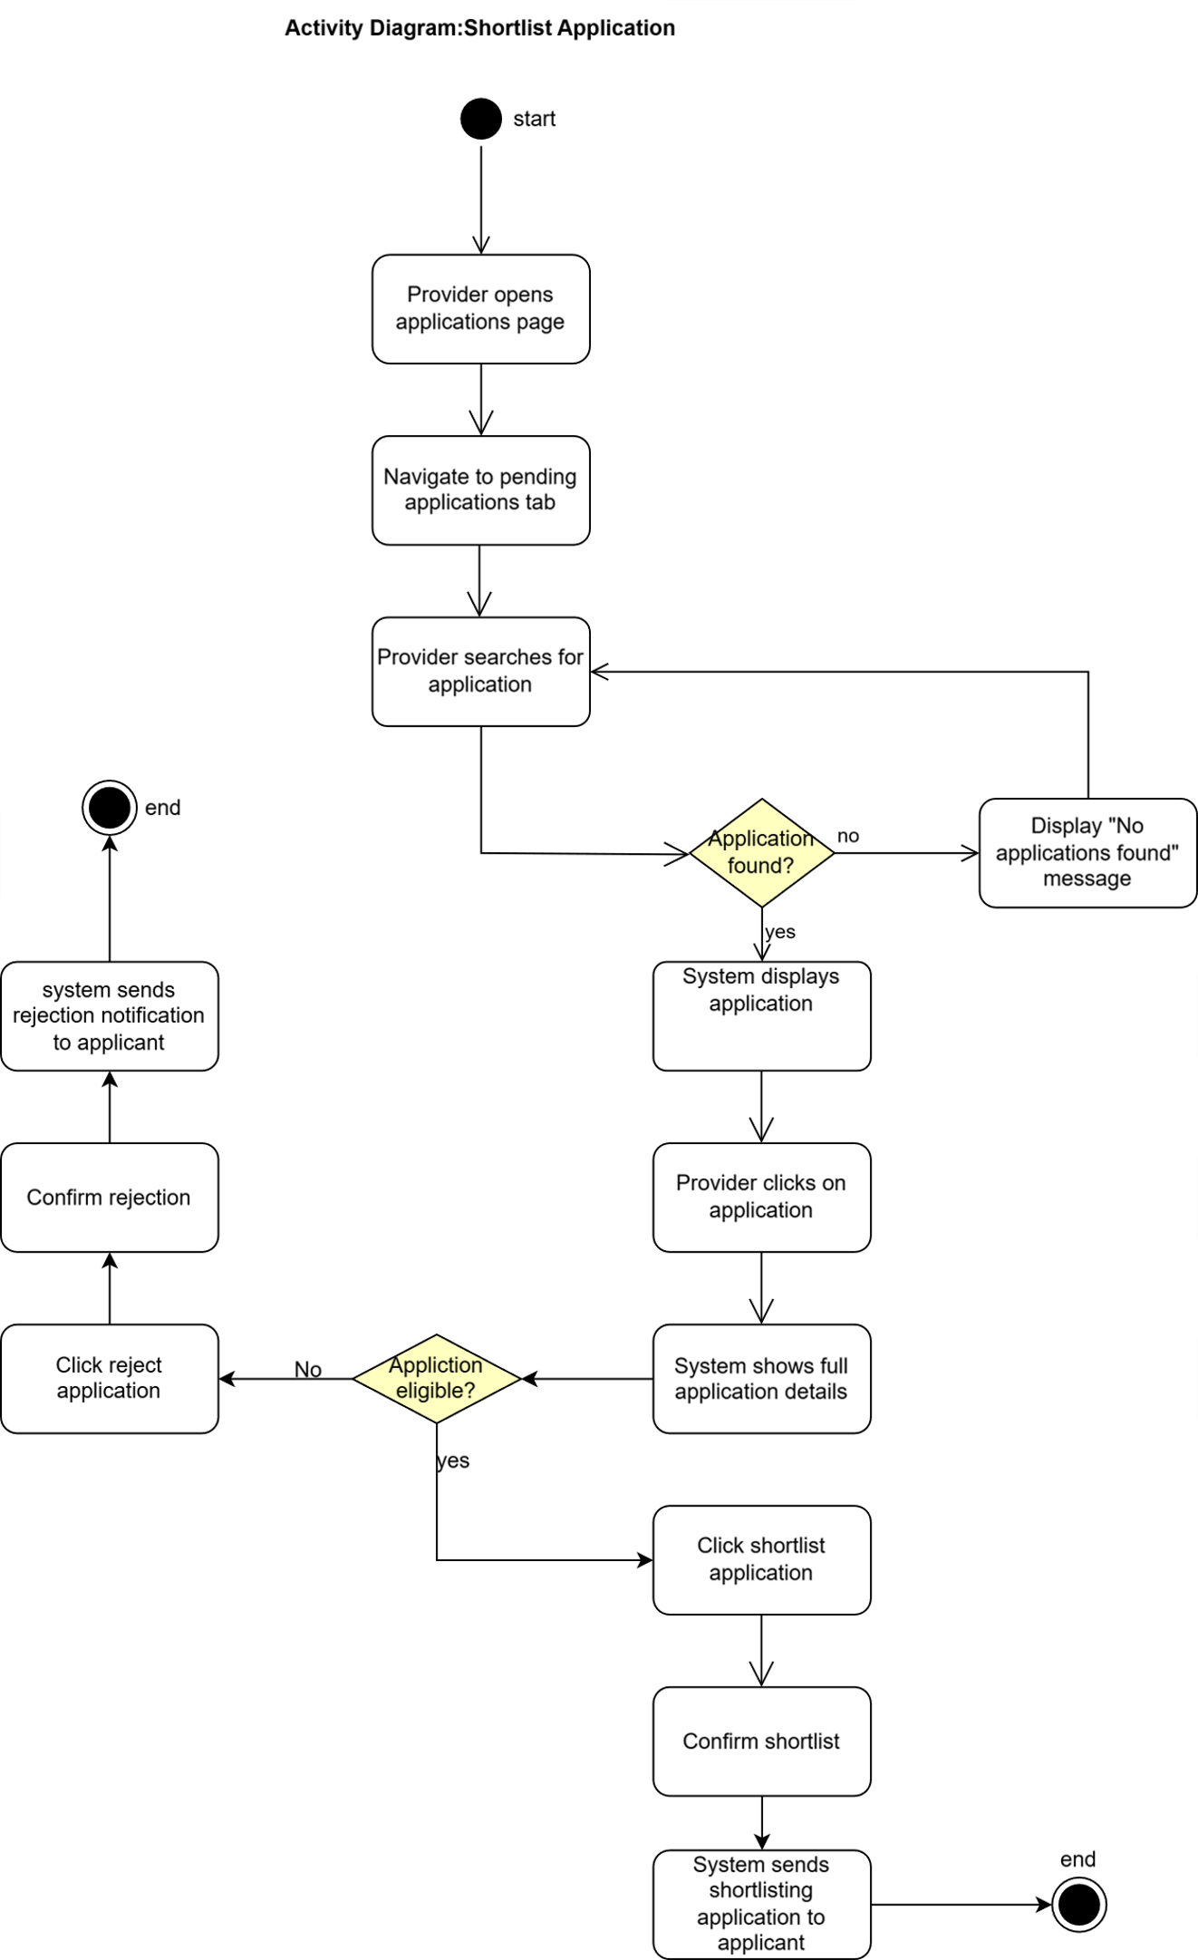

Logical View – Class Diagram (Notification Entity)

The class diagram represents the logical view of the system and shows the structure and relationships between the main entities. In this update, a new entity called Notification was introduced and is associated with the Applicant entity through a composition relationship. This means notifications belong directly to an applicant and cannot exist independently without one. The multiplicity shows that one applicant can have zero to many notifications, while each notification belongs to exactly one applicant.
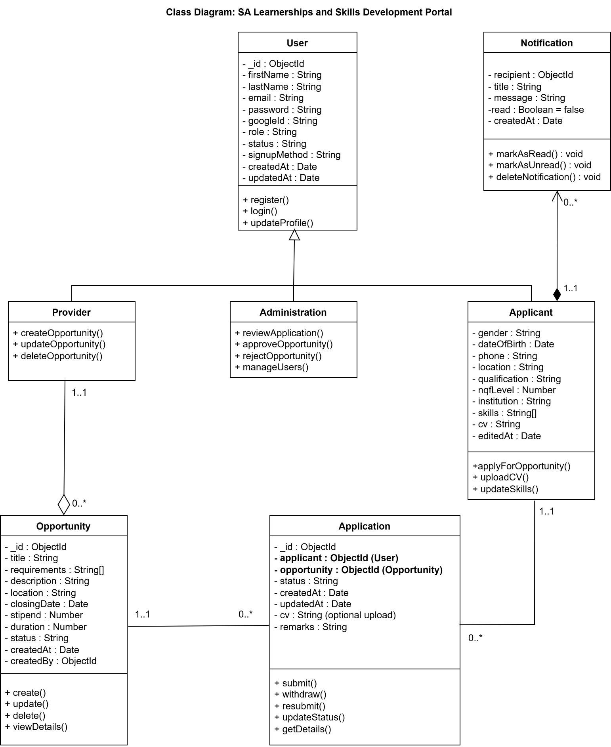

Scenario View – Use Case Diagram

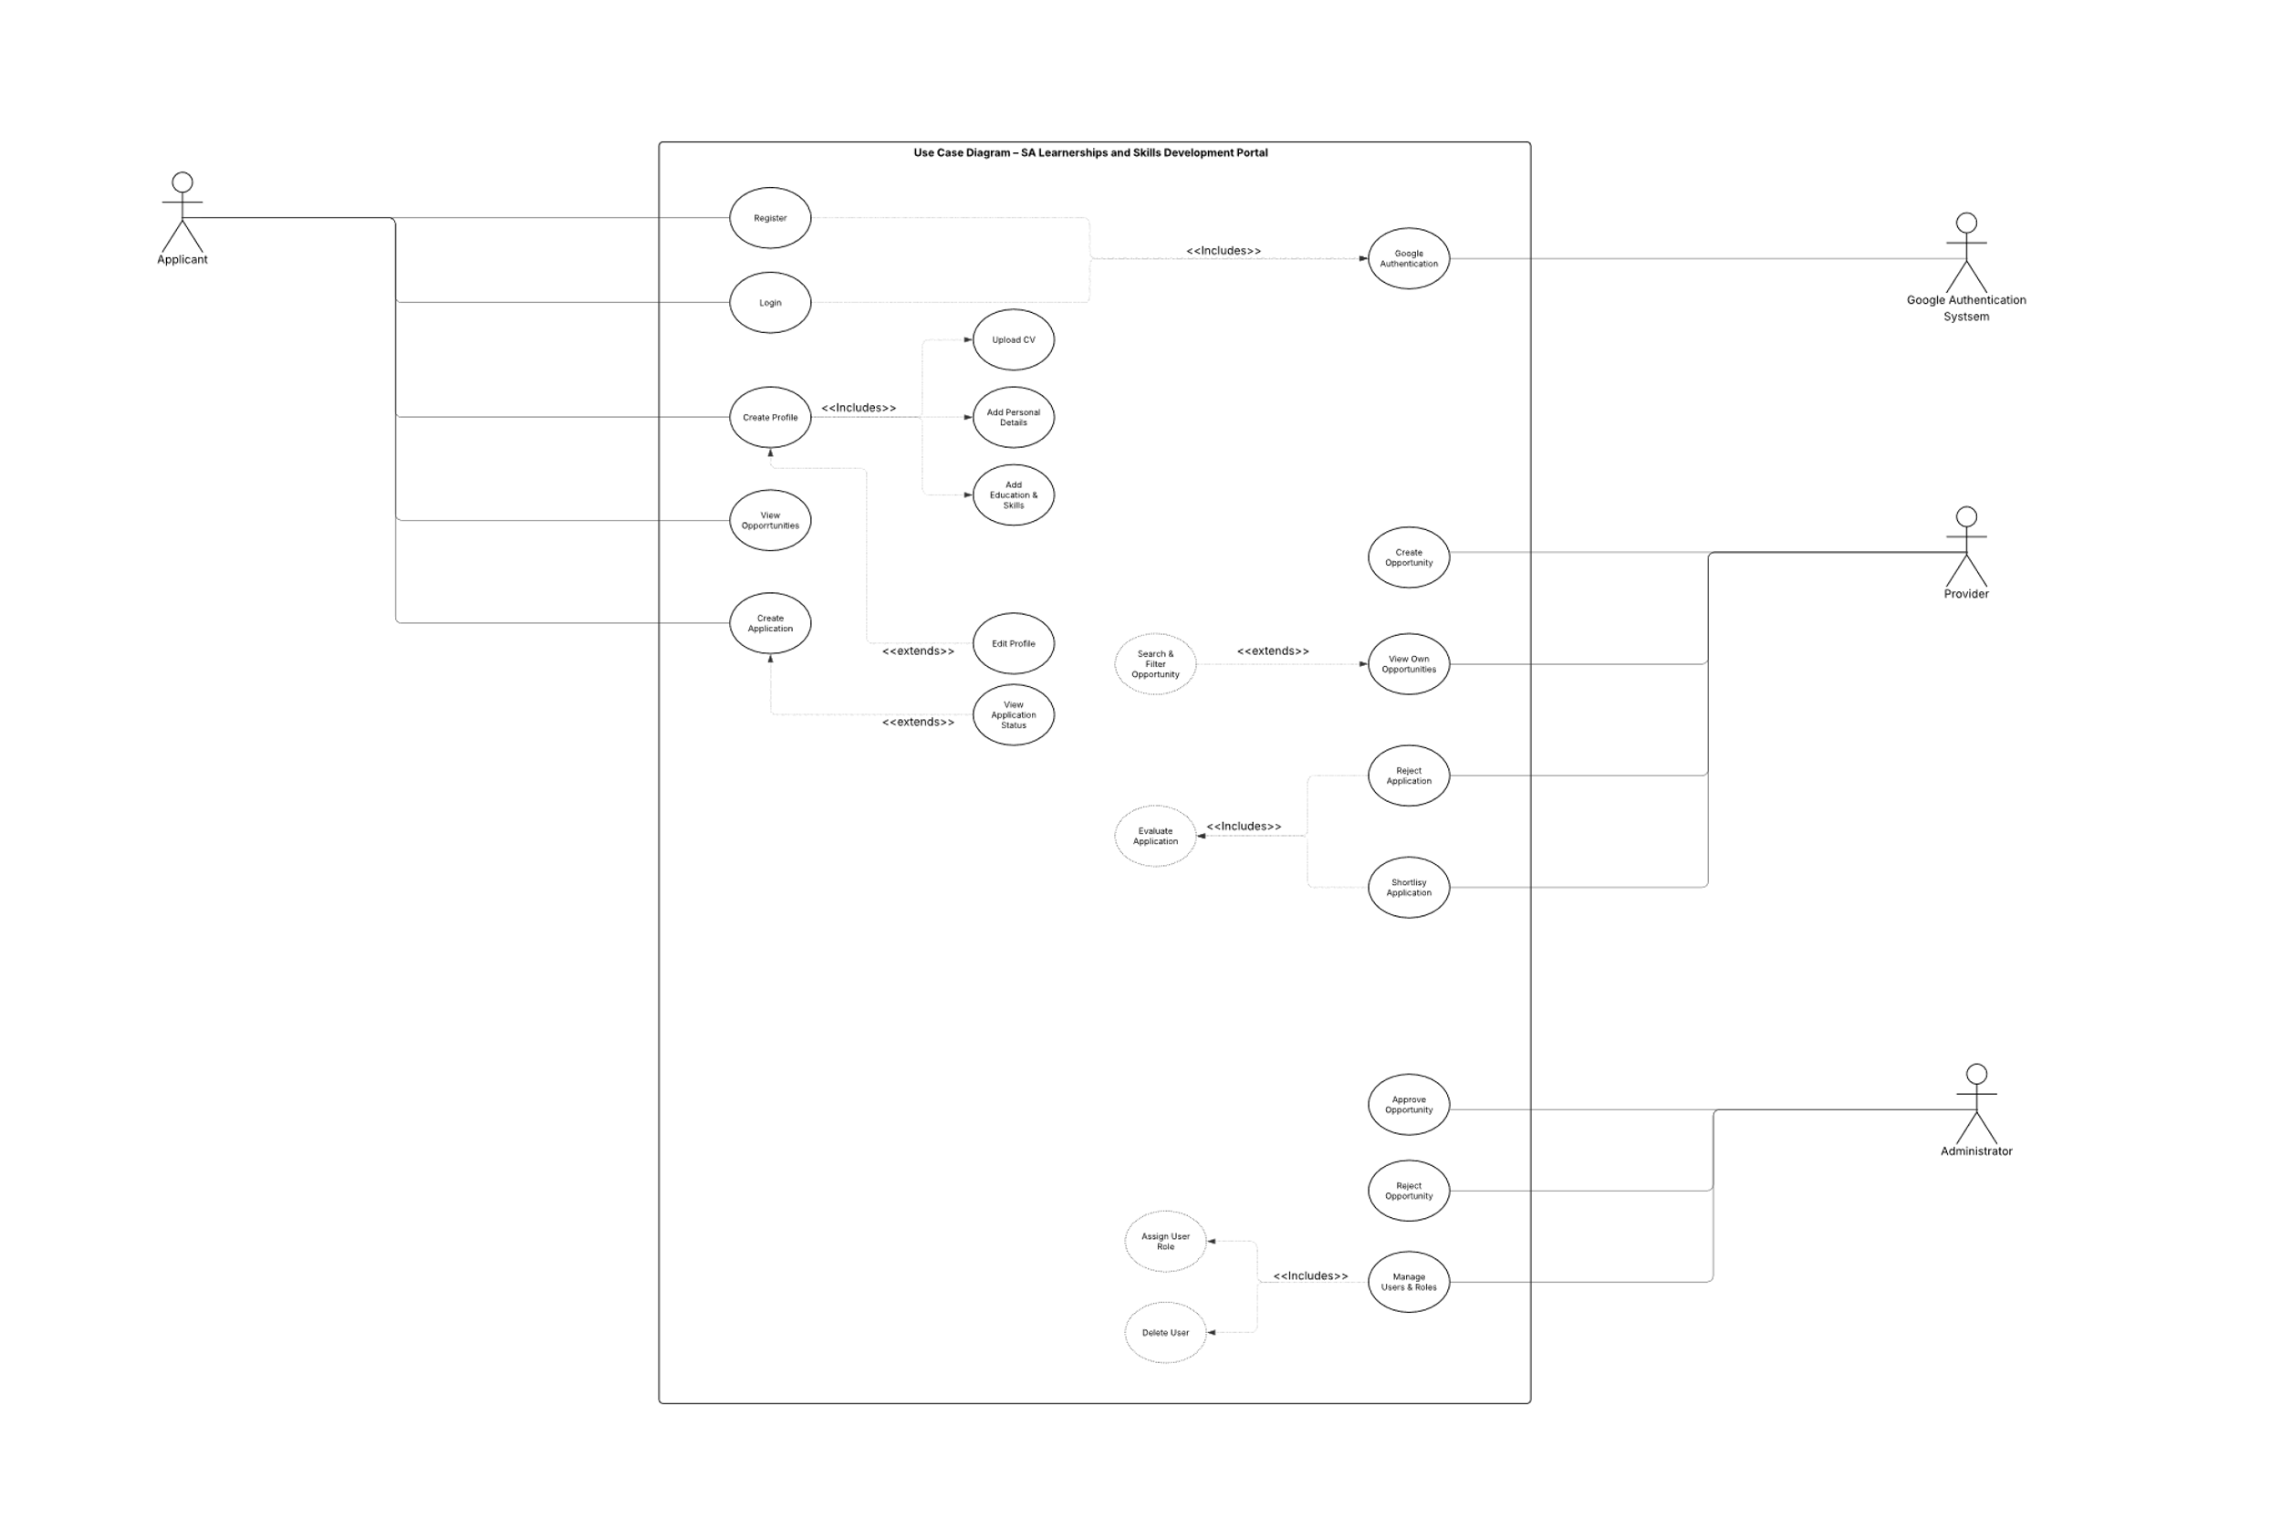

Physical View – Deployment Diagram

.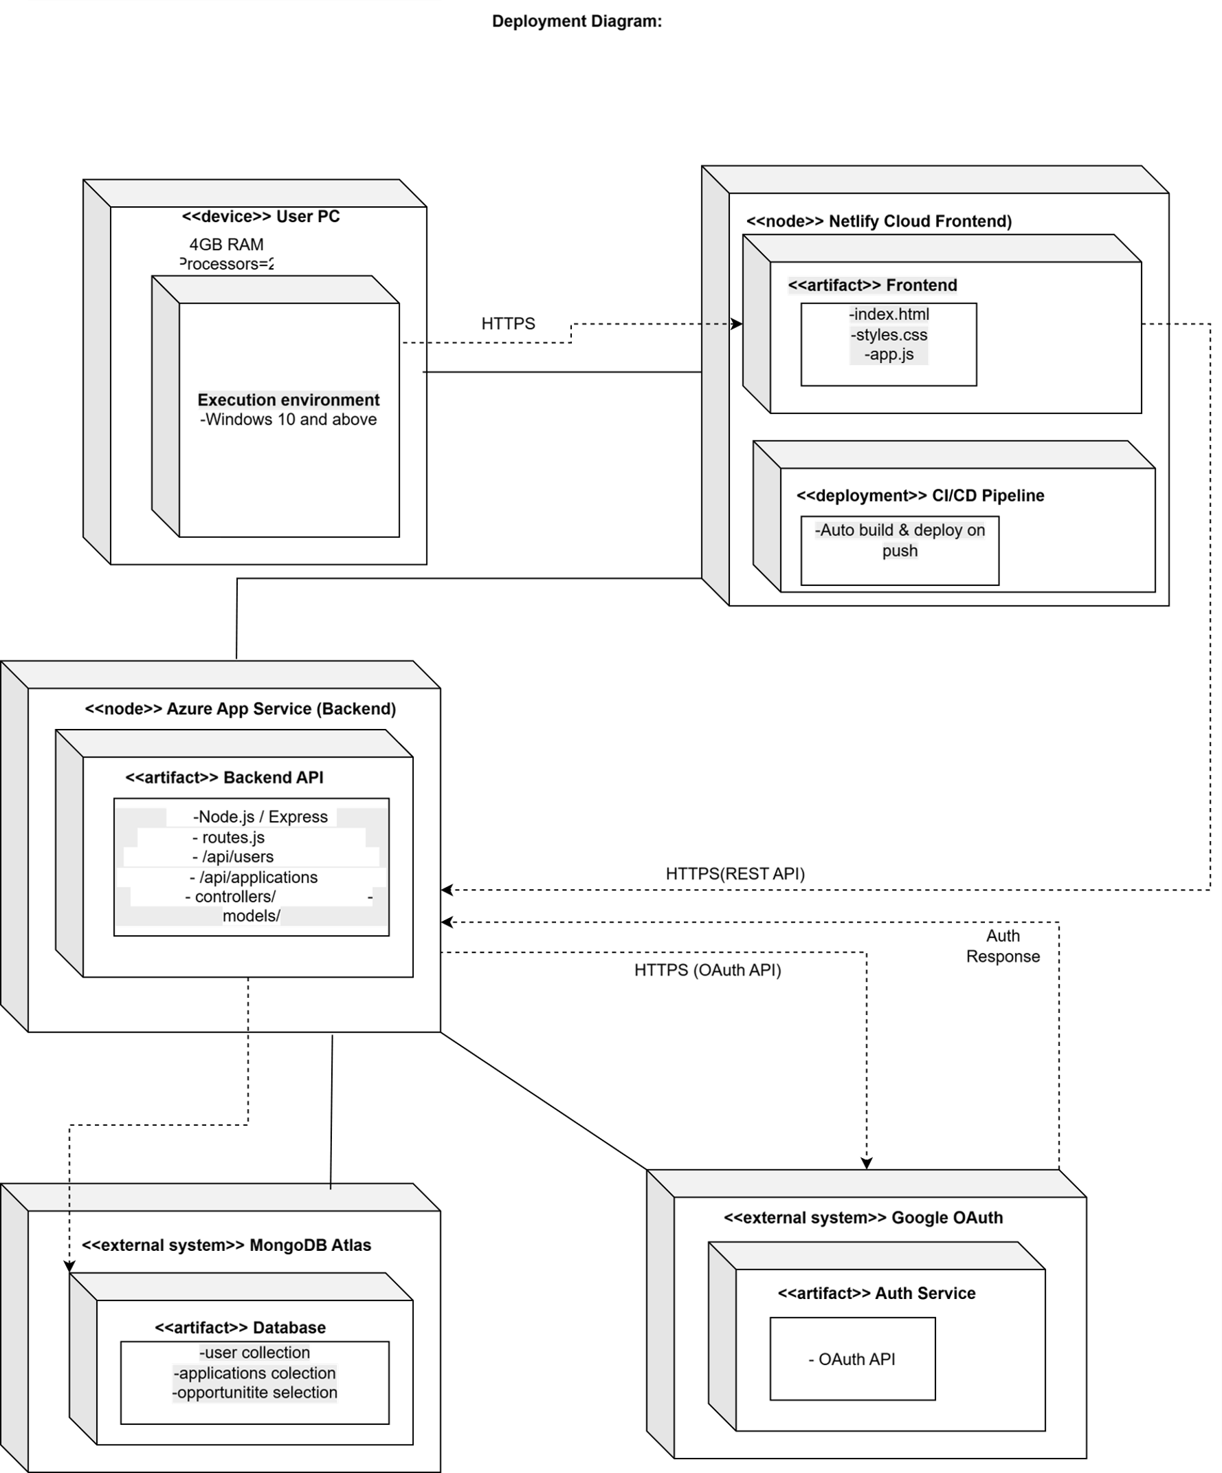

Logical View – State Diagram – User

